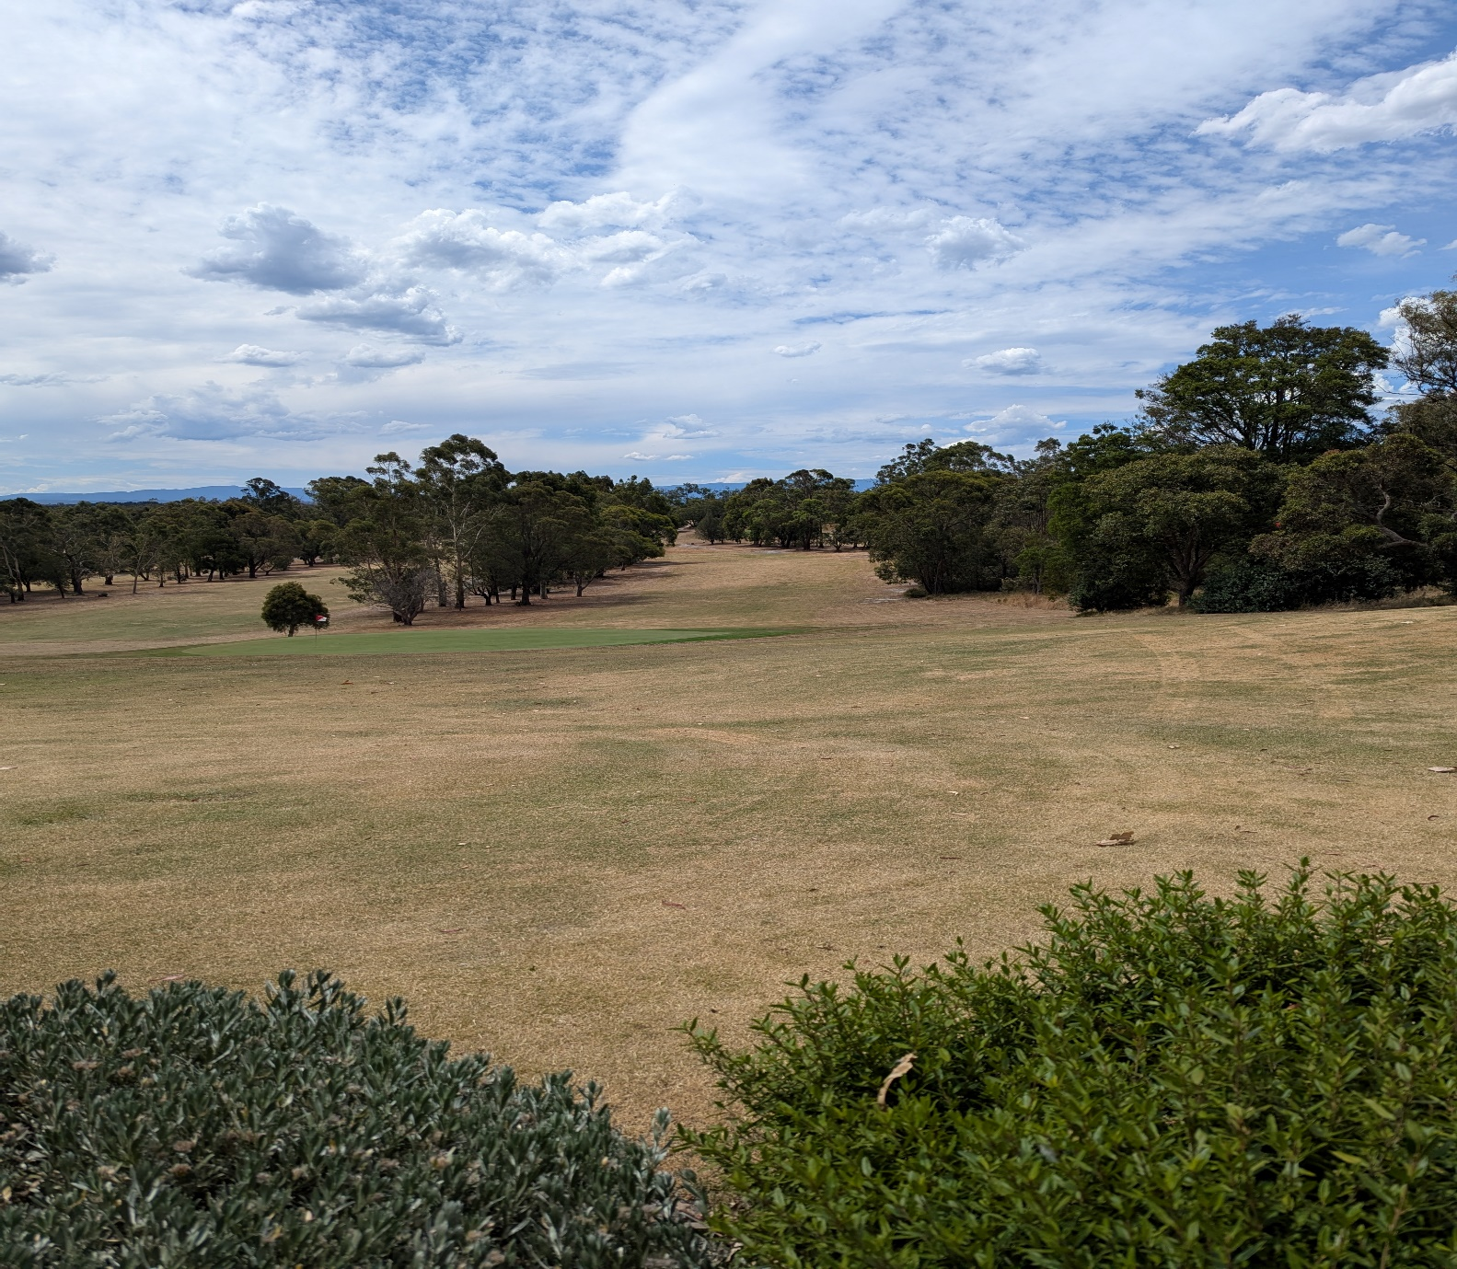

**TRAFALGAR**

**GOLF**

**CLUB**

**SPONSORSHIP**

**PACKAGES**

**Current as of 1/1/25**



Trafalgar Golf Club, founded more than 100 years ago, is a stunning 18 hole golf course, situated on the outskirts of picturesque Trafalgar, in West Gippsland, Victoria. We pride ourselves on being one of the best courses in Gippsland.

Our club boasts over 350 members, and we have locals, country members and visitors who come to our club each week, to enjoy our beautiful course and facilities.

We have a large clubhouse offering a bar, kitchen catering, and seating for more than 100 people.

We have club competitions Tuesday to Saturday, a twilight competition during Daylight Savings, and cater for men, women, senior and junior golfers. Pennant golf competitions featuring 75+ players at a time are played at our course several times a year. Trade Groups are welcomed on Sundays, bringing many more golfers to our club also. We often provide junior and beginner clinics, and golf lessons are available from nearby professionals.

Green fee players are in abundance at our club, and we get a vast amount of visitors to our club each week.

Our venue, featuring golf course, kitchen and bar, can cater for any event, and our staff and volunteers offer remarkable service and hospitality to members and guests alike.

AT PRESENT, WE ARE PROUD TO OFFER SIGNAGE PACKAGES AND SPONSOR MEMBER PACKAGES TO SUIT ALL BUDGETS.

A mutually beneficial partnership is assured when you join forces with our club, and we guarantee exposure to the hundreds of people who frequent our club every month.

We would love to have your partnering with us at Trafalgar Golf Club.

Please do not hesitate to contact us if you require further information about any of these sponsorship opportunites.



**TRAFALGAR GOLF CLUB**

**230 Gibsons road, P.O. Box 123, Trafalgar, Victoria, 3824**

**Phone (03) 5633 1110**

**Email** [**golf@trafalgargolf.com.au**](mailto:golf@trafalgargolf.com.au)

**Website www.trafalgargolf.com.au**

SPONSORSHIP PRICES:

TEE SIGN Small sign placed on or near tees around the course size 1000mm wide x 300mm high $360 per year

DRIVEWAY SIGN Larger sign placed in the driveway entrance size 2000mm wide x 800mm high $600 per year *

TEE SIGN PLUS One x 12 months free golf membership $1100 per year (save $88 per year)

TEE SIGN PLUS Two x 12 months free golf memberships $1900 per year (save $100 + per year)

TEE SIGN PLUS Three x 12 months free golf membership $2600 per year (save $200+ per year)

DRIVEWAY SIGN plus one x 12 months free golf membership $1400 per year (save $28 per year) *

DRIVEWAY SIGN plus two x 12 months free golf membership $2200 per year (save $56 per year) *

DRIVEWAY SIGN plus three x 12 months free golf membership $3000 per year (save $84 per year) *

* driveway sign packages also incur a one off $400 fee for artwork and installation costs.

All packages include your business advertised on our website and on our Clubhouse Sponsor TV.

Packages may be tailored to suit your needs if you require something not listed.

All sponsors receive a Sponsor Gift Pack, which includes certificate, photo of your sign, and some complimentary vouchers for golf and carts. Each year upon paid renewal, further complimentary vouchers are issued.

We are happy to discuss your interest in sponsoring other events at the club also. Don’t hesitate to call us.



**TRAFALGAR GOLF CLUB**

**230 Gibsons road, P.O. Box 123, Trafalgar, 3824**

**Phone (03) 5633 1110**

**Email** [**golf@trafalgargolf.com.au**](mailto:golf@trafalgargolf.com.au)

**Website** [**www.trafalgargolf.com.au**](http://www.trafalgargolf.com.au)

SPONSORSHIP AGREEMENT FORM

Business name……………………………………………………………………………………………………………………………………………………………………….

Address………………………………………………………………………………………………………………………………………………………………………………….

Email……………………………………………………………………………………………………………………………………………………………………………………..

Contact person: Name………………………………………………………………………….Mobile…………………………………………………………………….

Sponsorship package chosen………………………………………………………………………………………………………………………………………………….

Cost………………………………..Commencement Date………………………………………..Finish Date or UFN……………………………………………

All sponsorship monies are payable in advance. The sponsor will receive an invoice at the commencement of the agreement, and then be invited to renew annually. The sponsor must abide by the payment terms of the invoices or sponsorship/signage will be removed immediately and further action will be taken to recover monies owed. The sponsor is responsible for paying for any changes they require to the sign during the period of sponsorship. Trafalgar Golf Club MUST be notified by email/phone if/when the sponsor wishes to cease their membership.

On behalf of sponsor: Name………………………………………………..……..Signature…………………………………………Date……………

TGC representative: Name………………………………………………………Signature…………………………………………Date……………