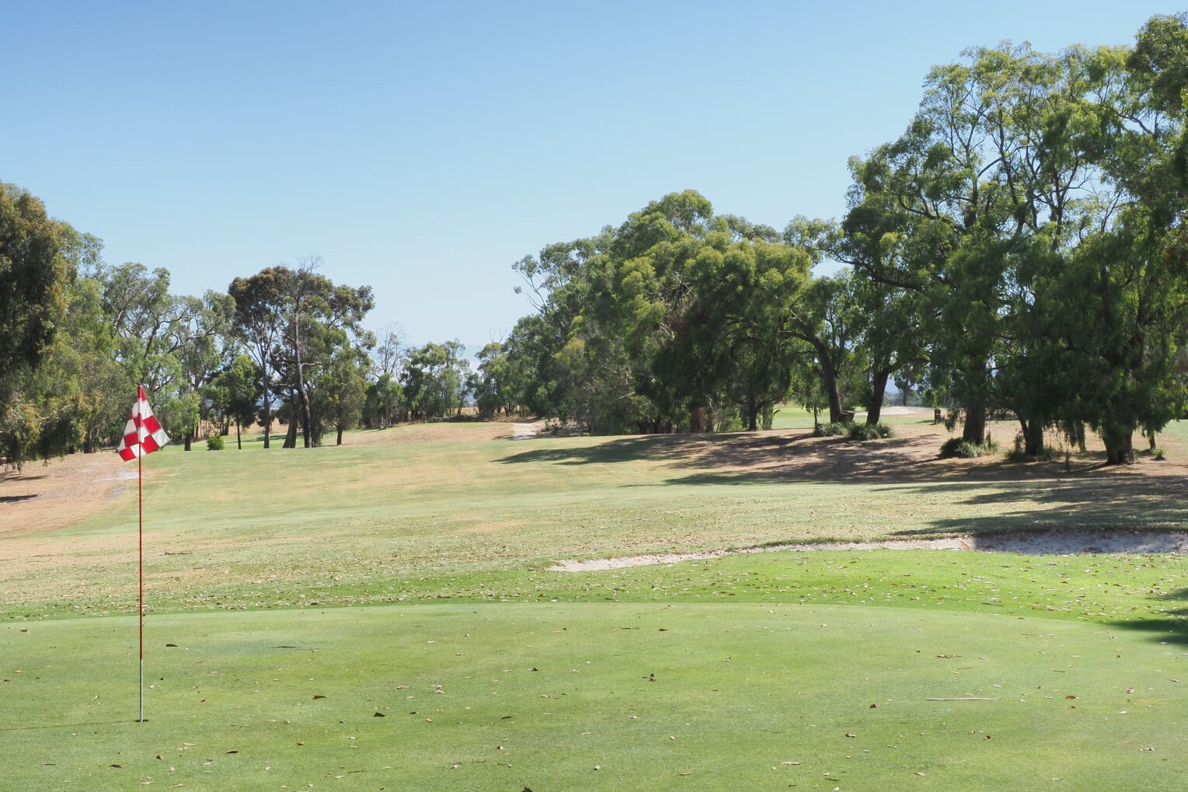
Sponsorship By-Laws Policy Document
Version 1 – February 2019

230 Gibsons Road
Trafalgar Victoria 3824
Phone Clubhouse (03) 5633 1110
Email: admin@trafalgargolf.com.au
Website: www.trafalgargolf.com.au

Sponsorship Information Pack
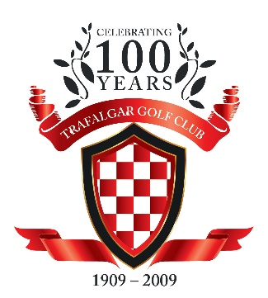

Trafalgar Golf Club Inc.
230 Gibsons Road,
Trafalgar, Vic. 3824
Phone Clubhouse (03) 5633 1110
Email – admin@trafalgargolf.com.au
Website – www.trafalgargolf.com.au

Dear Sirs,
Trafalgar Golf Club, founded more than 100 years ago, is a beautiful 18 hole golf course, situated on the outskirts of picturesque Trafalgar, in West Gippsland, Victoria. It was recently rated one of the top ten courses in regional Victoria.
Our club boasts over 350 members, including local players, and country members who travel long distances to spend time at our club.
We have a large clubhouse offering a bar, kitchen catering, and seating for more than 100 people. We have club competitions Tuesday – Saturday, a twilight competition during Daylight Savings Time, Veterans competitions, and cater for men, women, senior and junior players. Pennant golf competitions featuring 75+ players at a time are played at our course several times a year. Seniors Week, a Government initiative sees many senior golfers attending our course annually. Trade groups are welcomed on Sundays, bringing many more golfers to our club also.
We cater for functions, weddings, birthdays, trade groups etc, and our staff and volunteers offer good old fashioned friendly service and hospitality to members and guests alike.
At present we can offer you signage packages, event sponsorship packages and corporate packages, with a variety of prices to suit any budget.
A mutually beneficial partnership is assured when you join forces with our club, and we guarantee exposure to the thousands of visitors we have to our club each year.
We would love to have you partnering with us at Trafalgar Golf Club.
Please do not hesitate to contact us if you require any further information.
Thanking you in anticipation,
Sponsorship Department
Trafalgar Golf Club

Brian Barnes – Sales – 0427 528 096
Jenny Moss – Admin – 0408 175 014
PACKAGE 1
TEE SIGN SPONSORSHIP
COST $350 PER YEAR

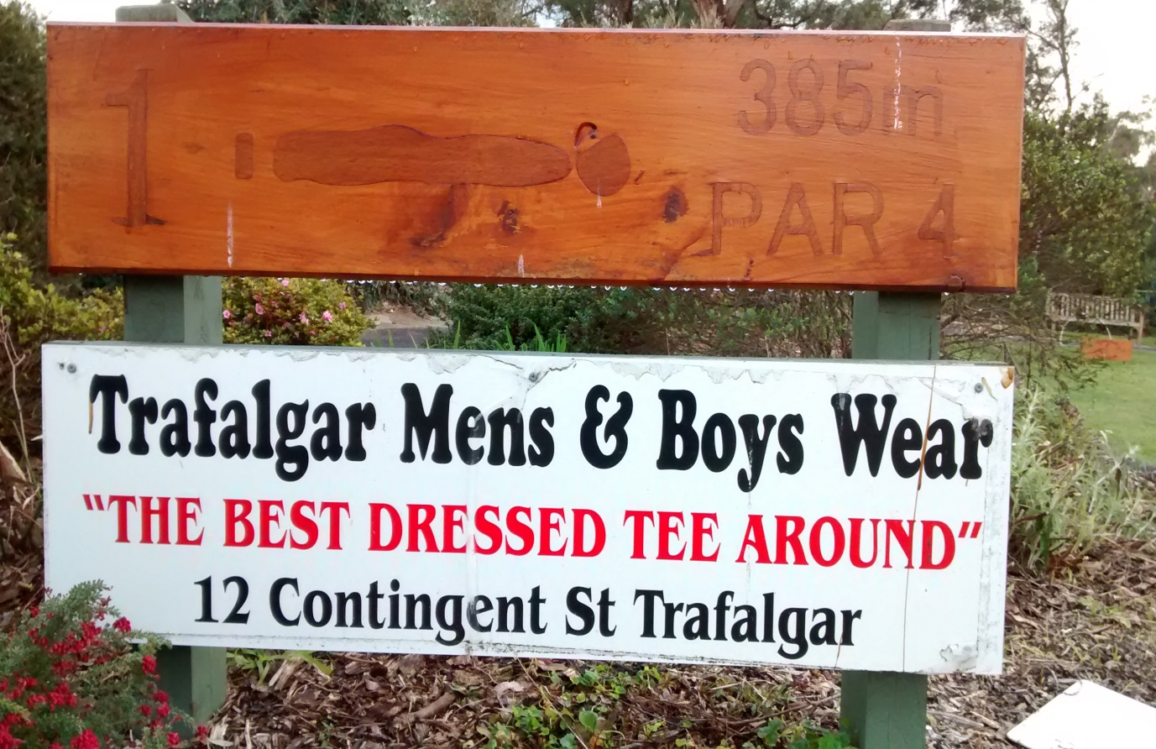
Package includes:
Your business advertised on a permanent sign situated on or near a tee.
Link to your business on our website.
Your business logo placed on our Clubhouse TV Sponsors screen.
An invitation to our Annual Sponsors Day golf event.
Four free rounds of golf vouchers.

PACKAGE 2
MOTORISED CART SPONSORSHIP
COST $440 PER YEAR

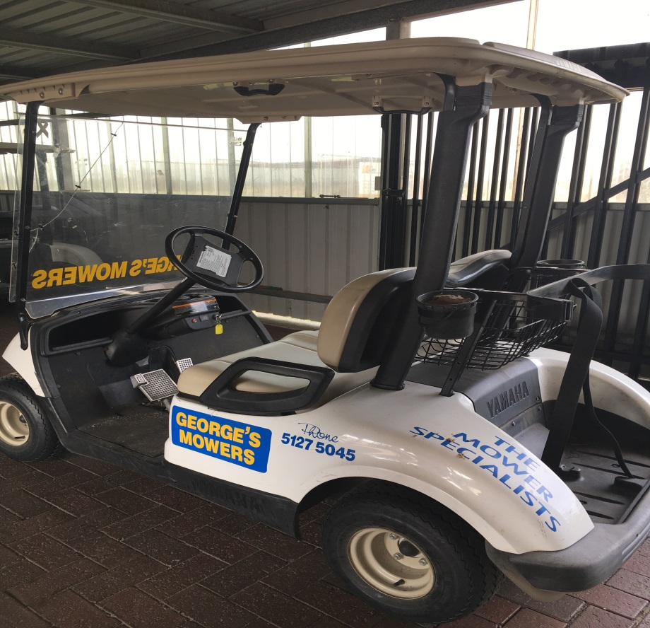
Package includes:
Your business advertised on one of our motorised carts.
Link to your business on our website.
Your business logo placed on our Clubhouse TV Sponsors screen.
An invitation to our Annual Sponsors Day golf event.
Four free rounds of golf vouchers.
PACKAGE 3
DRIVEWAY SIGNAGE
COST $600 PER YEAR
(plus a one off $400 artwork fee)

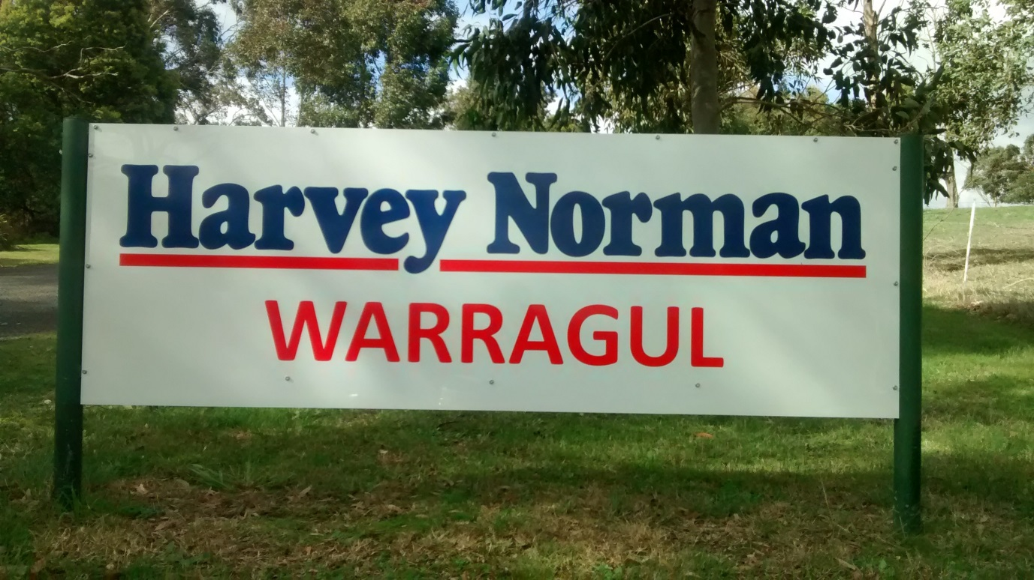
Package includes:
Your business advertised on a large sign situated on our driveway for maximum exposure.
Link to your business on our website.
Your business logo placed on our Clubhouse TV Sponsors screen.
An invitation to our Annual Sponsors Day golf event.
Four free rounds of golf vouchers plus 2 free cart hire vouchers.

PACKAGE 4
MAJOR SIGNAGE
Price on Application

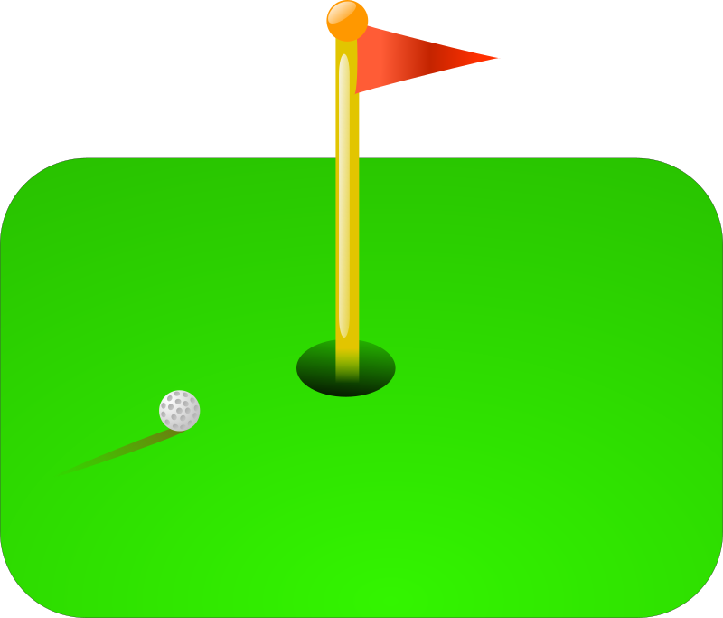
Package includes:
Your business advertised on a Very Large Sign, around the club.
Link to your business on our website.
Your business logo placed on our Clubhouse TV Sponsors screen.
An invitation to our Annual Sponsors Day golf event.
Four free rounds of golf vouchers plus 4 free cart hire vouchers.

PACKAGE 5
DONATIONS OF GOODS / VOUCHERS
Cost decided by sponsor
Package Details:
Don’t want a sign but happy to show support in other ways?
Trafalgar Golf Club is always grateful for any donations, be it goods or vouchers from your own business, big or small.
These donations are used for raffle prizes.
We have a monthly raffle plus other larger raffles and events during the year.
In return, we would advertise your business on the day the raffle is held, and send you a certificate of appreciation.

PACKAGE 6
EVENT SPONSORSHIP
Cost – See below
Trafalgar Golf Club holds several events each year, and we seek sponsors to be associated with them.

MONTHLY MEDAL - $125 per month
We seek a sponsor each month for our Monthly Medal competition. Your business would get naming rights, be mentioned in all advertising and newsletters, and be promoted during the day.
BIG KAHUNA
This is an annual event held Feb-April every year. It is a popular event for club members only. Your business would get naming rights, be mentioned in all advertising and newsletters and promotions for this event. At the final in April, we invite you to set up a trestle table with your products, business cards, flyers etc, to really show people what your business is all about. You are welcome to come along on the day.
TRAFALGAR PLATE
This is our major event for the year. It is a hugely popular event for club members and members from other clubs. More than a hundred people will see your advertising on this huge day. Sponsor will get 1 promotional sign around the club, a trestle table so you can set up a showcase of your products, flyers, etc. You will get naming rights, and be mentioned in all advertising and promotions for this event. We invite you to come along and speak and present trophies on the day.

OTHER OPPORTUNITIES CAN BE DISCUSSED UPON REQUEST
PACKAGE 7
CORPORATE NETWORKING SPONSORSHIP
COST $2000 PER YEAR
(or $1800 per year without signage)
Come and enjoy a monthly game of golf with your clients, suppliers, workmates, or employees at our beautiful golf course!
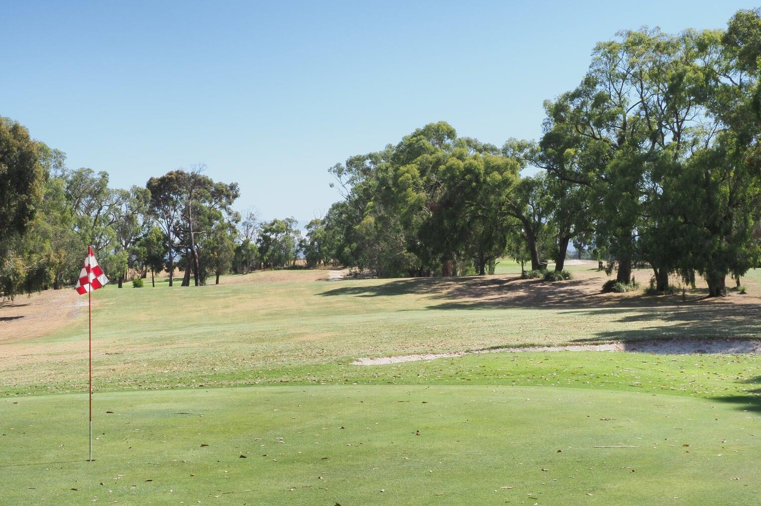
This package includes:
Four free rounds of golf EVERY month for a year. (based on 18 holes).
Two free cart hires EVERY month for a year.
One advertising sign around course, 1m wide x 30cm deep
One 10% off membership fees voucher, should anyone like to join as a member.
A link to your business on our website.
Your business logo on our Clubhouse TV Sponsors Screen.

PACKAGE 8
PRE PAID VOUCHERS
COST AS PER BELOW
These vouchers are available for purchase by individuals, businesses, members, and visitors and
are to be used by non-members.

These vouchers are for Free Rounds of Golf and
Free Cart Hire, either for 18 holes or 9 holes !

Treat your family and friends, your clients, your employees!
Great gift idea!
Discounted prices represent great value!

FREE ROUND OF GOLF – 18 HOLES FREE ROUND OF GOLF – 9 HOLES
Buy 5 = $100 (save $25) Buy 5 - $60 (save $15)
Buy 10 = $200 (save $50) Buy 10 - $120 (save $30)
Buy 20 = $400 (save $100) Buy 20 - $240 (save $60)

FREE CART HIRE – 18 HOLES FREE CART HIRE – 9 HOLES
Buy 5 = $175 (save $25) Buy 5 = $85 (save $15)
Buy 10 = $350 (save $50) Buy 10 = $170 (save $30)
Buy 20 = $700 (save $100) Buy 20 = $340 (save $60)

